|  |
| --- |
|  |
| 新概念 3 册 |
| Lesson2 |

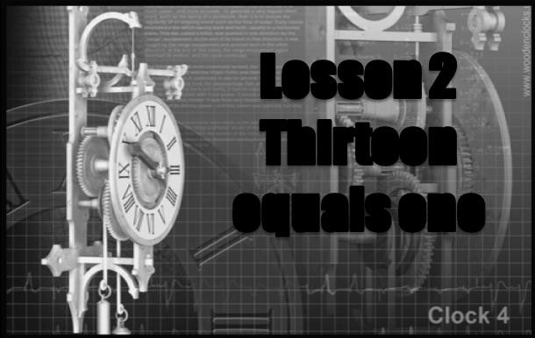

词汇

# equal ['i:kwəl]

**v. 等于**

He **equaled** the world record. 相等

Nobody **equals** him in strength. 相匹敌

Nobody **matches** him in strength. 相匹敌

In English she has **no equal** in her class.

no=not any 后接单数

**be / stand head and shoulders above sb.**

**be much better than others**

明显超过他人，鹤立鸡群

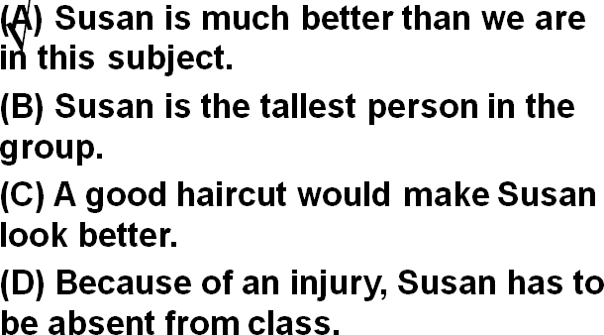

In computer programming, Susan is head and shoulders above the rest of us. Answer:

(A) Susan is much better than we are in this subject.

Women demand equal pay for equal work.

A is equal to B equality

**racial** equality

**sexual** equality

We wish to inform you that we specialize in garments for more than twenty years, and shall be pleased to establish business relations with you on the basis of equality and mutual benefits.

# raise [reɪz]

**v. 募集，筹措**

raise one’s hand

raise one’s voice

raise one’s hat to sb.

raise one’s glass to sb.

raise the roof 大吵大闹

raise pigs 养猪

He has a big family to raise.

We’re raising a fund for orphans.

读音

rise arise arose arisen

Problems arose. 问题出现

arouse 激起

arouse one’s pity / anger …

―You look happy today.

―Yes. I got a **raise**. (做名次)涨工资

We pay two thousand Yuan monthly to start. It's our policy to hire on a trial basis. If you work out all right after three months you will be put on the permanent payroll and be given a raise.

课文

1.Our vicar is always raising money for one cause or another, but he has never managed to get enough money to have the church clock repaired.

**be always doing sth.** 老是做某事（贬义）

He is always being late.

People are always talking about the problems of youth.

听力：

W: Mary is always complaining about her job.

M: Maybe if you try typing letters every day, you'd see what it's like.

Q: What does the man mean?

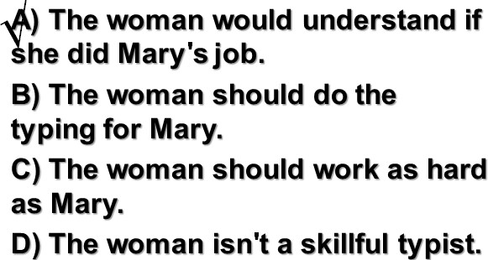

Answer: A) The woman would understand if she did Mary's job.

**be forever doing sth.** 老是做某事（贬义）

He is forever talking about the friendly people, the clean atmosphere, the closeness to nature and gentle pace of living.

**be constantly / continually doing sth**. 老是做某事（贬义）

The boys are constantly / continually arguing.

美剧对话：

Your behavior reflects on me, and I can't do my job if you're constantly humiliating me.

Constantly? Aside from today, give me one example.

keep (on) doing sth. 老是做某事（贬义）

From the moment he arrived there, he kept on pestering his doctor to tell him when he would be able to go home.

In the process, he enjoyed himself thoroughly and kept telling everybody how much he hated hospitals.

**do sth. all the time 老是做某事**

**托福听力真题**

W: I thought the doctor said you should stay off your foot until the swelling goes down.

M: She did. It just makes me uncomfortable to ask my friends **to wait on me all the time**.

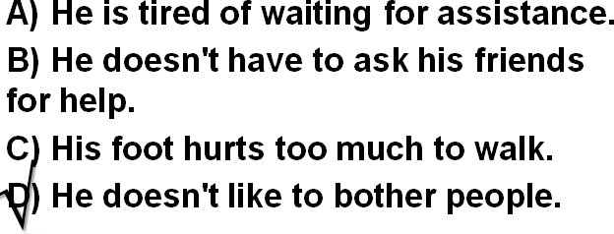What does the man mean?

D) He doesn't like to bother people. Sam, mess up the kitchen (always) Sam is always messing up the kitchen.

举例：

Bruce, leave his dirty dishes on the table

**(forever)** Bruce is forever leaving his dirty dishes on the table.

Peter, try to show me he’s smarter than me

**(constantly)** Peter is constantly trying to show me he is smarter than me.

Mary, borrow my clothes without asking me

**(continually)** Mary is continually borrowing my clothes without asking me.

Why, you, make the same mistakes

**(keep on doing)** Why do you keep on making the same mistakes?

Jane, forget to give me my phone messages

**(do sth. all the time)** Jane forgets to give me my phone messages all the time.

**cause** 原文中表示“理由”

One would expect them to know their parts by heart and never have cause to falter.

**one … or another** 各种各样的

**one cause or another** 各种各样的理由

He is always asking me for money for **one cause or another**.

Beginners will err at **one time or another.**

Everyone can contribute to society in **one way or anothe**r.

**one … after another** 一个又一个

one day after another 一天又一天

encounter one difficulty after another 一个又一个的困难

achieve one success after another 一个又一个的成果

**manage to do**: 设法完成了某事

As no pumas had been reported missing from any zoo in the country, this one must have been in the possession of a private collector and somehow managed to escape.

**fail to do**: 没能完成某事

When the journalist again failed to reply, the editor reluctantly published the article as it had originally been written.

**have sth. done** 请某人做某事 / 某种（不愉快的）经历

I'm going to have my hair cut this weekend.

… people would rather pay large sums of money than have their life work destroyed by gangsters. King CharlesⅠhad his head cut off.

The house had its window broken in the explosion.

**无灵主语 / 物称主语 (inaminate subject)**

Lesson1: When reports came into London Zoo that a wild puma had been spotted forty-five miles south of London, they were not taken seriously.

Lesson32: The sea bed was scoured with powerful nets and there was tremendous excitement on board when a chest was raised from the bottom.

举例：

He lost his confidence.

Confidence deserted him.

I couldn't sleep that night.

That night sleep eluded me.

We only travelled half the distance at sunset.

Sunset met us halfway.

The past few years witnessed the great influx of foreigners to China, for travelling, studies or business.

造句：我的小女儿总是抱怨 (complain of) 各种各样的病，但她从未成功地得到允许 (get permission) 呆在家里。

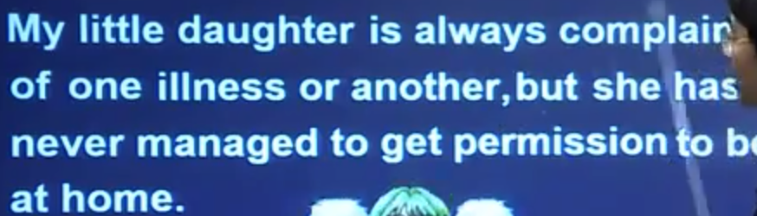

2.The big clock which used to strike the hours day and night was damaged many years ago and has been silent ever since.

**used to do** 过去曾经/常常 (现在不了)

I used to get up early.

**be / become / get used to n./doing** 习惯于做某事

I'm used to getting up early.

'We'll get used to that, Bill,' said the vicar. Life is not fair, get used to it. — Bill Gates

**be accustomed to (doing) sth.** 习惯于做某事

4册,Lesson3: For men **accustomed to eating** seven-course dinners and sleeping between fine linen sheets at home, the change to the Alps must have been very hard indeed.

**strike the hours** 钟打点报时

2册,Lesson9: It would strike twelve in twenty minutes.

**ever since: adv. / prep. / conj.** 从那以后，一直……(用完成时）

There are countless people who, ever since their early years, have learned to associate snails with food. 本句话做介词

You know how she feels about you.

It's been the same way **ever since** we were kids. 做连词

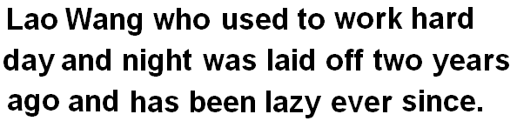造句：过去日夜辛苦工作的老王两年前下岗 (be laid off) 了，从那以后就变得懒了。

3.One night, however, our vicar woke up with a start:the clock was striking the hours!

**wake (up): vi & vt.** 醒了; 唤醒…

The doorbell rang loud enough to wake the dead.

**go / get to sleep** 入睡/睡着

**fall asleep**

**toss and turn 辗转反侧,难以入眠**

I was **tossing and turning** all night. insomnia

He suffered from insomnia. 失眠

**sit up /** **stay up** 熬夜

He sat up all night, preparing for the exam.

**night owl** 夜猫子

He is a **night ow**l.

**start n.** 激灵（由于恐惧或惊讶身体突然的一动）

**wake (up) with a start** 一激灵醒了

She woke from the dream **with a start**.

**with + 名词(作状语修饰谓语动词)** 更正式的表达

The officer went through the case **with great care**.

He had spotted a tiny bottle at the bottom of my case and he pounced on it **with delight**.

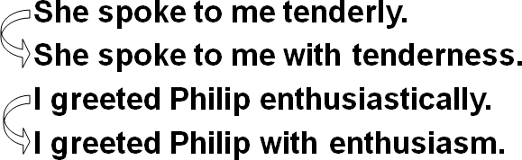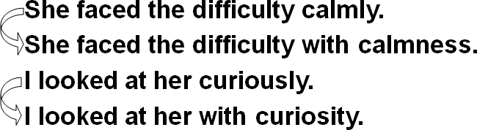Then I added **with a smile**.

His few material possessions make it possible for him to move from place to place **with ease**.

4.Looking at his watch, he saw that it was one o'clock, but the bell struck thirteen times before it stopped.

Looking at his watch, he saw that it was one o’clock,

… When he looked at his watch, he saw that it was one o’clock.

**非谓语 (doing; done; to do) 作状语时，一般情况下其隐含的主语应该与主句主语保持一致。**

Looking at his watch, it was one o’clock. X

**before 的译法**

**强调主句的时间很长时,译为"才”**

It will be a long time before we meet again.

**强调主句的时间很短时,译为”就”**

I hadn’t waited long before he came.

5.Armed with a torch, the vicar went up into the clock tower to see what wasgoing on.

**arm sb. with sth.**

Armed with a torch, the vicar went up into the clock tower 逻辑主语宾语,用被动

**… sb. carry sth.**

Carrying a torch, the vicar went up into the clock tower 逻辑主语宾语,用主动

**... go on v.** 发生（多用进行时表示正在发生的事）

What’s going on here?

**表示”发生”:**

**happen**

**occur**

**come up**

**come about**

**take place (一般强调计划发生的事)**

**strike 表示一个事故突然发生**

**ensue 随之发生**

**coincide (with …) 与某事同事发生**

举例:

The funeral will **take place** on Monday.

Most people were fast asleep when the earthquake **struck**.

I objected to his advice and a heated argument **ensued**.

When I came, he was just about to leave.

My arrival **coincided with** his departure. catch sight of …

6.In the torchlight, he caught sight of a figure whom he immediately recognized as Bill Wilkins, our local grocer.

**caught sight of …** 一眼看见

**catch a glimpse of …**

**glimpse …**

figure

A farm worker, who stayed up all night, claimed to have seen a **figure** cutting corn in the moonlight.

One of the most colorful figures in boxing history was Daniel Mendoza, who was born in 1764.

**recognize … as …**

I recognized her as one of my classmates.

**注意读音: 4种发音音变**

**grocer grocery**

**音变1: s + j = ʃ**

this year Bless you. I promise you.

**音变2: t + j = tʃ**

last year don’t you won’t you statue

**音变3: d + j = dʒ**

did you would you graduate credulous

**音变4: z + j = ʒ**

May I use your book? How’s your father?

7.'Whatever are you doing up here Bill?' asked the vicar in surprise.

'I'm trying to repair the bell, ' answered Bill.

**“疑问词+ever ”有两个含义**

**表示 “无论…**”

**Wherever** it went, it left behind it a trail of dead deer and small animals like rabbits.

**表示 “到底…” 加强语气**

**whenever, wherever, whoever, whichever ...**

**Wherever** did you go yesterday?

**When ever** am I going to see you again?

**on earth “到底…”**

What **on earth** has happened to trouble you so?

**in the world “到底…”**

What in the world are you doing here at seven in the morning?

**in God’s / heaven’s name “到底…”**

What **in God's name** was that huge bang?

Where **in heaven's name** have you been?

**the hell**

What **the hell** was that noise?

How **the hell** are we going to do that?

8.'I've been coming up here night after night for weeks now.

**have been doing**

**现在完成进行时:** 表示持续性的动作一直到现在，而且还有可能继续下去。

**夜复一夜**

**night after night**

**night by night**

**every night**

**one night after another**

**日复一日**

**day after day**

**day by day**

**every day**

**one day after another**

Oceans apart, day after day, and I slowly go insane.

**for weeks 好几周了**

**for hours 好几小时了**

**for months 好几个月了**

**for years 好几年了**

**for centuries 好几百年了**

9.You see, I was hoping to give you a surprise.'

**was / were hoping …** 表达一种试探性的，委婉的语气。

I **was hoping** you could marry me.

10.'You certainly did give me a surprise!' said the vicar.

**强调肯定式 (emphatic positive)**

在肯定句和祈使句中，在谓语动词前加上助动词 do 以加强语气。只用于一般现在时 (do, does) 和一般过去时 (did) 中。

I **do** need a car.

He **does** speak English well.

So you **did** come after all.

Come in. **Do** come in.

Shut up! **Do** shut up!

11.'You've probably woken up everyone in the village as well.

**as well …也…**

**as well as … 除了…之外, …也…**

You’ve probably woken up everyone in the village as well as me.

12.Still, I'm glad the bell is working again.'

**still 尽管如此，还是 …**

**nevertheless**

**nonetheless**

**all the same**

**just the same**

The girl is not beautiful. **Still**, I like her very much.

Nevertheless / nonetheless / all the same / just the same, I like her very much.

**三大从句: 形容词性的从句 (定语从句), 副词性的从句(状语从句),名词性从句(主语从句,表语从句,宾语从句,同位语从句)**

**特殊从句:形容词补足语**

Still, I’m glad (**that**) the bell is working again.

…, but I’m afraid (**that**) at one o’clock it will strike thirteen times and there is nothing I can do about it.

13.'That's the trouble, vicar, 'answered Bill. 'It's working all right,

but I'm afraid that at one o'clock it will strike thirteen times and there's nothing I can do about it.'

**there is nothing I can do about it** 对此我无能为力

**is out of order** 出故障了

The telephone **is out of order**, and **there is nothing I can do about it**.

I know you are not satisfied, but **there is nothing I can do about it.**

We apologize for this, but **there is nothing we can do about it.**

14.'We'll get used to that, Bill, 'said the vicar.

'Thirteen is not as good as one, but it's better than nothing.

**as good as: almost** **(ad.)** 几乎……；和……差不多

The injured man **is as good as** dead.

Everything is **as good as** settled.

As far as I could see, it needed only a minor adjustment: a turn of a screw here, a little tightening up there, a drop of oil and it would be **as good as** new.

15.Now let's go downstairs and have a cup of tea.'

**be not one’s cup of tea** 不适合某人

Swimming **is not my cup of tea**.

Mountain hiking **is not my cup of tea**.

**make tea** 沏茶

**make water** 撒尿